ReactJS Hands-on 10 - Office Space Rental App (JSX & Inline CSS)

Commands Used
- npx create-react-app officespacerentalapp
- cd officespacerentalapp
- npm start

Project Structure

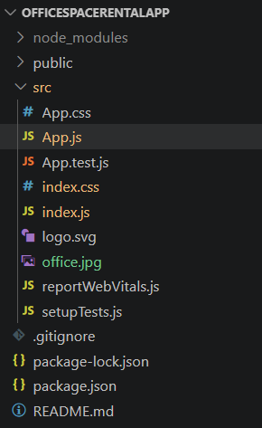

App.js
import React from "react";
import officeImage from "./office.jpg";
function App() {
const office = {
Name: "Skyline Business Center",
Rent: 55000,
Address: "Madhapur, Hyderabad"
};
const officeSpaces = [
{ Name: "Skyline Business Center", Rent: 55000, Address: "Madhapur, Hyderabad" },
{ Name: "Tech Park Offices", Rent: 75000, Address: "Hitech City, Hyderabad" },
{ Name: "Green Valley Workspace", Rent: 45000, Address: "Gachibowli, Hyderabad" }
];
return (
<div style={{ margin: "30px" }}>
<h1>Office Space Rental App</h1>
<img
src={officeImage}
alt="Office Space"
width="400"
height="250"
/>
<h2>Featured Office</h2>
<p><b>Name:</b> {office.Name}</p>
<p>
<b>Rent:</b>
<span style={{
color: office.Rent < 60000 ? "red" : "green",
marginLeft: "5px"
}}>
₹{office.Rent}
</span>
</p>
<p><b>Address:</b> {office.Address}</p>
<hr />
<h2>Available Office Spaces</h2>
{officeSpaces.map((item, index) => (
<div
key={index}
style={{
border: "1px solid gray",
padding: "15px",
marginBottom: "15px",
width: "400px"
}}
>
<p><b>Name:</b> {item.Name}</p>
<p>
<b>Rent:</b>
<span style={{
color: item.Rent < 60000 ? "red" : "green",
marginLeft: "5px"
}}>
₹{item.Rent}
</span>
</p>
<p><b>Address:</b> {item.Address}</p>
</div>
))}
</div>
);
}
export default App;

index.js
import React from "react";
import ReactDOM from "react-dom/client";
import "./index.css";
import App from "./App";
const root = ReactDOM.createRoot(document.getElementById("root"));
root.render(
<React.StrictMode>
<App />
</React.StrictMode>
);

index.css
body{
font-family: Arial;
margin:0;
}

Output
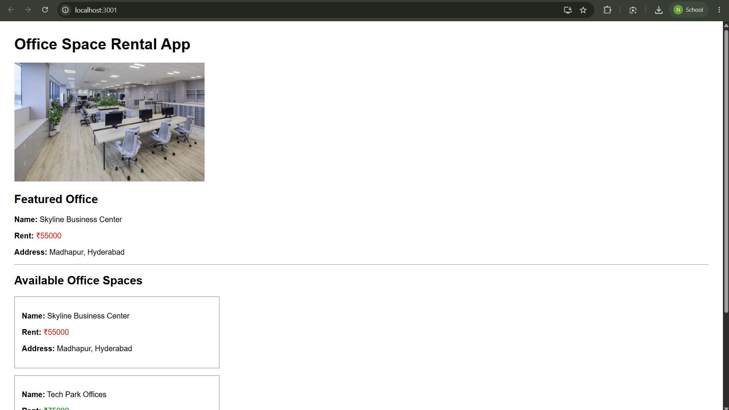

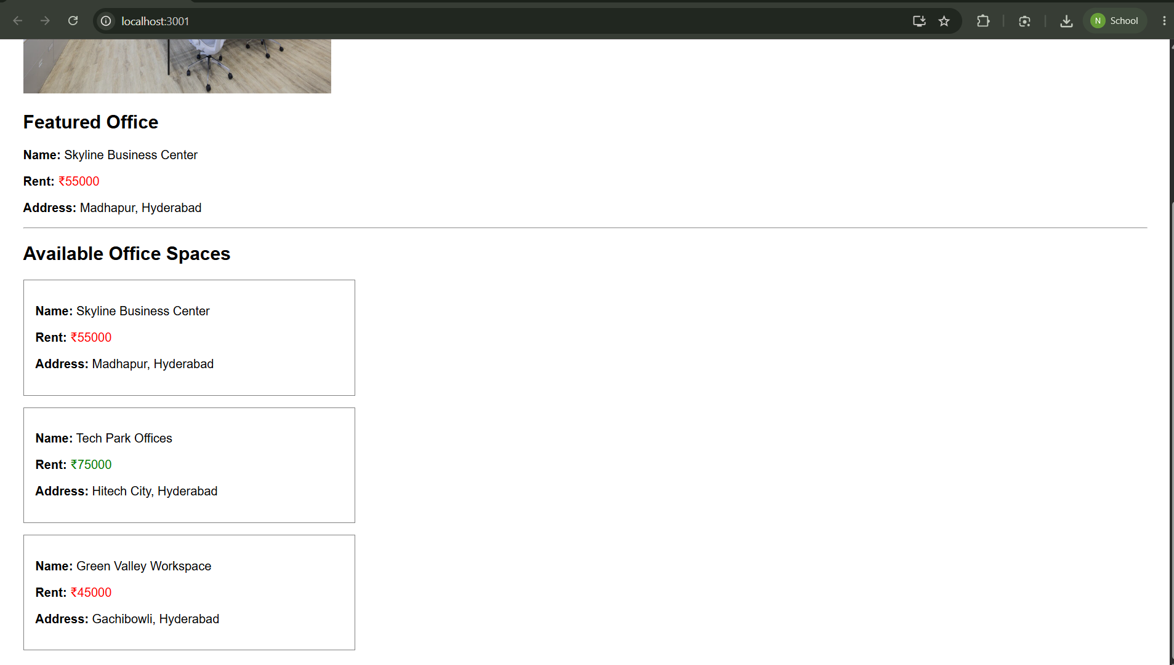

Conclusion
The Office Space Rental application was implemented successfully using JSX, inline CSS, conditional rendering for rent color, image rendering, and the map() function to display multiple office space records.

